TED Blog
The evocative world of the six-word memoir: A Q&A with new TED ebook author Larry Smith
Posted by: Jim Daly December 20, 2012 at 1:15 pm EST

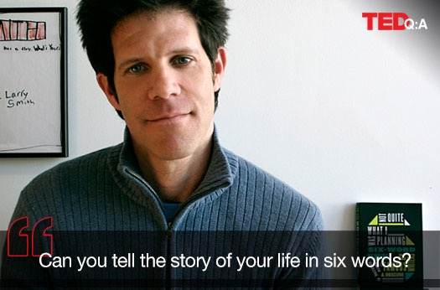
Pause for a moment and imagine the grand, confusing and ultimately exhilarating drama that is the sweep of your life. Think you can summarize it into a half-dozen carefully crafted words? Larry Smith thinks you can, and created the popular ‘Six-Word Memoir‘ project, that challenges contributors to make us pause, reflect and even laugh. He has just published his latest edition as a TED Book, and added a special twist: artwork.

Smith put out the call for students — ranging from grade school to graduate school — to contribute illustrated Six-Word Memoirs. The result is the evocative and often moving Things Don’t Have To Be Complicated: Illustrated Six-Word Memoirs By Students Making Sense of the World. Today, the Washington Post features a slideshow of just a few of the mini-memoirs and images from the book. So below, we asked Larry Smith all about how Six-Word Memoirs came to be.

How did the idea for Six-Word Memoirs come about?
There’s a legend that Ernest Hemingway was once challenged to write a story in only six words. He wrote: “For sale: baby shoes, never worn.” I was inspired by that. Others had played with the idea of the six-word story form before, but I and my storytelling community, SMITH Magazine, re-imagined it. So in November 2006, we partnered with a little-known company called Twitter for what was then supposed to be a one-month contest to win an iPod. The idea is as simple as it sounds: tell the story of your life in exactly six words. Those six words can be an attempt to sum up your whole life. Think of it as the title of your autobiography or epitaph on your tombstone. Chef Mario Batali certainly did when he wrote, “Brought it to a boil often.” Others try to capture one aspect of their life such as, “According to Facebook we broke up” or “Mom’s Alzheimer’s: she forgets, I remember.” At its core, Six-Word Memoir projects takes a basic human need—self-expression—and makes it accessible, easy and often quite addictive.
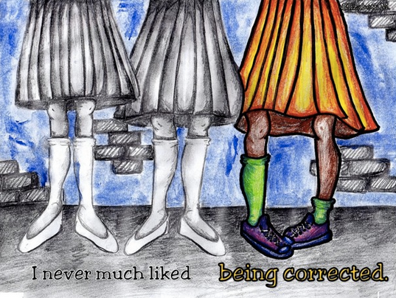
From Elizabeth Mappus, a junior at the Academic Magnet High School in North Charleston, S.C. Click the image to see The Washington Post‘s slideshow.

This is the first illustrated memoir you’ve done. Why add the art?
As with most of what happens in a passionate community, I took the lead of the people in it. Soon after the Six-Word Memoir project took off I began hearing from teachers who were adapting Six-Word Memoirs in their classroom, from grade schools in the Bronx to Yale Law School. It was used in English and art classes alike. One grade-school teacher in New Jersey had her students create six-word “memory boxes.” At Parsons School of Design, illustrated Six-Word Memoirs are a regular assignment. Whether a Six-Word Memoir takes the form of just words, or words and images, video, or 3-D collage, the constraint fuels rather than inhibits creativity. So when TED approached me and asked, ‘What’s the Six-Word Memoir book you’re most jazzed to do?,’ it was an easy answer: a book that’s a celebration of the artful works of students and, I hope, an even more effective catalyst for educators everywhere. So we put out a call for submissions.

How many submissions did you get?
We had around 2,000 submissions, often from entire classrooms.

How many did you choose for the book?
Between the 60 individual memoirs you see in the book, and the classroom slideshows (in which we feature all the work the teachers sent in) we have fewer than 200 in the book. There’s one part I don’t like about my job: telling people—of any age—that they haven’t been chosen for the book. The end result isn’t necessary “the best” but a selection that I hope offers a wide range of ages, themes, ideas and forms of self-expression. We’ll be featuring many more memoirs not found in the book at smithmag.net/school, where teachers can also download our free teachers’ guides.
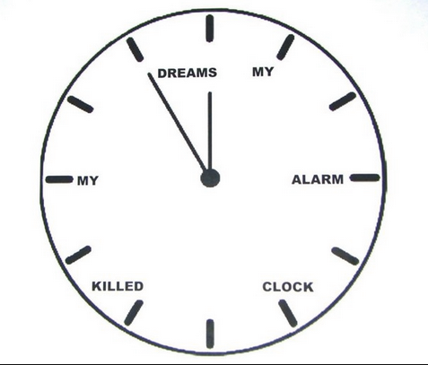
From Shawn Budlong, a seventh grader at the Thurgood Marshall School in Rockford, Ill. Click the image to see The Washington Post‘s slideshow.

What surprised you about the responses of the students?
I was surprised by the depth of feeling and the angst and the life lessons that they may not have even realized they were sharing. I mean, does the little girl who wrote the memoir that said “Tried surfing on a calm day” even know she’s a Zen master? Now I absolutely expect brilliance and have seen it first hand at school across the country and every day on the site. I was a little surprised by how good some of the artwork was, but I probably shouldn’t have been. And I also didn’t expect to get so many impassioned notes from teachers lobbying for their students’ work to make it into the book.

Childhood is a confusing time. What major themes did you see?
One theme that came through clearly is about actively taking life into your own hands—memoirs like “This time Cinderella demanded it back” and “Break the rules now and then.” There are unsurprisingly a number of memoirs on technology, but with more of a melancholy vibe than I had expected: “Life is better with headphones on,” “Feeling small in a mechanical world,” and “Honey, your dinner is getting cold,” where you see a teen girl surrounded by gadgets and looking pretty lost. And while many of the memoirists haven’t been on earth too long, they’re wise beyond their years and ready to dole out life lessons. The beautifully illustrated, “There’s no such things as secrets,” is as true as it gets in 2013.
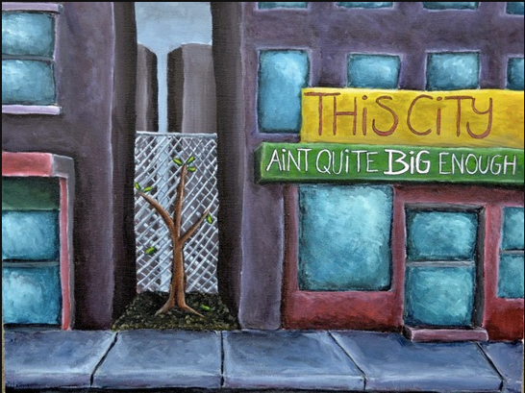
From Lydia Bernatovicz, a senior at the Grand Island High School in Buffalo, N.Y. Click the image to see The Washington Post‘s slideshow.

Any favorites or memoirs that have particularly touched you?
The whole Six-Word Memoir project is oddly intense. Think about it: people have decided to share a little piece of themselves with strangers. If they’re lucky they’ll end up in a book so many strangers can peer into their lives. When the submissions are coming from students—most teens or pre-teen—and they’ve worked hard to create an illustration, it’s impossible not to be moved by so much of what comes in. One that really hit me is, “They said to follow my dreams.” In her illustration you see an empty bed and a trail of those six words leading out a window and into the world. It feels like the beginning of a Maurice Sendak story. Another is called, “Going back to the happy days,” and we see a girl playing hopscotch; the author is a junior in high school and already nostalgic for a simpler time. And then there’s kind of a goofy one that just brings a smile to my face every time I look at it. It’s by a fourth grader whose Six-Word Memoir is, “Bears are my number one fear.” Next to a drawing of this scared kid you see a big bear with the words, “Humans are my number fear.” It reminds me that everything is really a matter of perspective.

How can readers contribute to future Six-Word Memoir projects?
That’s easy. Go to SmithMag.net/sixwords or SmithTeens.com and share as many Six-Word Memoirs are you like. Some people share just one, others thousands. The Six-Word Memoir project is very much an example of the Network Effect: we get better with each new person who gets the six-word bug.
.
Things Don’t Have To Be Complicated is part of the TED Books series. It available for the Kindle and through the iBookstore. Or download the TED Books app for your iPad or iPhone.

