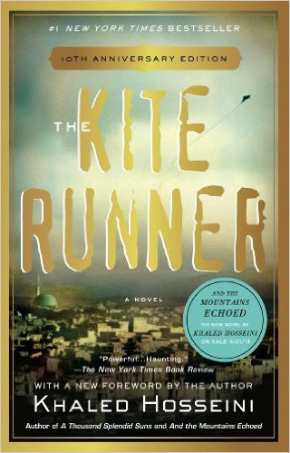

Name: Date: Period:

**Close Reading Organizer - Chapter 10**

**Directions:** Read each summary entry and think about which themes listed in the Themes Key apply to it, then color

in those themes in the Theme Tracker. Next, write a few sentences of Analysis to explain how the themes you chose apply to each summary section.

**Themes Key**

Betrayal

Redemption

Fathers and Children Violence and Rape Memory and the Past Politics and Society

**Summary**

**Theme Tracker**

**Your Analysis**

The story jumps to March of 1981. **Amir** and **Baba**, along with several others, are in the back of a truck fleeing Afghanistan for Pakistan. The drive is bumpy and makes Amir feel car sick, which Baba sees as another of Amir’s weaknesses. They had to flee at night and leave no evidence of their escape, because informers are everywhere. Afghanistan is under the control of Afghan communists and Russian soldiers. They have turned everyone against each other, and people inform on each other for money or under duress.

1

2

3

4

5

6

The driver, **Karim**, is first taking them to Jalalabad, where his brother will drive them the rest of the way to Peshawar, Pakistan.

Karim has an arrangement with the Russian soldiers that guard the road. They arrive at a checkpoint, and a young Russian soldier eyes a woman in the truck and decides to increase the price of passing through – he wants half an hour with the woman.

1

2

3

4

5

6

6

5

4

3

2

1

**Summary**

**Theme Tracker**

**Your Analysis**

**Baba** stands up and tries to shame the Russian soldier, but the soldier says there is no shame in war. Baba still won’t stand aside and the soldier threatens to shoot him. **Amir** tries to get Baba to sit down, but he pushes Amir away. Just before the soldier shoots, another Russian stops him. When the truck starts moving again, the young woman’s husband kisses Baba’s hand.

1

2

3

4

5

6

When the truck reaches Jalalabad, **Karim** tells them that his brother **Toor** can no longer take them to Peshawar, as his truck broke down the week before. **Baba** is furious that Karim kept this information from them just so he could get paid for his leg of the journey, and he attacks Karim and starts strangling him until the young woman asks him to stop.

1

2

3

4

5

6

The group then joins a larger group of refugees who are staying in a basement. **Amir** recognizes **Kamal** among them, but he looks sickly and old. Amir overhears Kamal’s father explaining what happened to him – four men caught Kamal while he was out alone and raped him, and now Kamal no longer speaks, but just stares.

1

2

3

4

5

6

**Karim** finally finds a way to get the refugees to Pakistan, but it is not his brother’s truck – it is a fuel truck. Before they get in the truck **Baba** picks up a handful of Afghan dirt, kisses it, and stows it in a snuff box next to his heart. Inside the truck it is terrifyingly dark and the air is thick with fumes, which makes it hard to breathe. **Amir** is saved from his panic by the small light of Baba’s wristwatch. Baba whispers in his ear to think of something happy, and Amir immediately thinks of a day flying kites with **Hassan**.

1

2

3

4

5

6

**Summary**

**Theme Tracker**

**Your Analysis**

They arrive in Pakistan and unload the truck. **Amir** is saddened by the sight of **Baba**’s two suitcases – the result of all his life’s work, along with “one disappointing son.” Suddenly **Kamal**’s father starts screaming, as Kamal isn’t breathing. Kamal’s father lunges for **Karim** and wrests his gun away. Before anyone can stop him, he puts the gun in his own mouth and pulls the trigger.

1

2

3

4

5

6